**WEATHER FORECASTING USING AI**

 A Project Report

                        Submitted in the partial fulfillment of the

                          requirements for the award of the degree of

**BACHELOR OF TECHNOLOGY**

**In**

**DEPARTMENT OF COMPUTER SCIENCE ENGINNERING**

**By**

**U.CHANDRAHAS- 2320030041**

**J.YASHWANTH- 2320030388**

**I.CHAITANYA PRAKASH-2320030396**

Under the Esteemed Guidance of

**LECTURE NAME**

**P.VENKATESWARA RAO**





**K L (Deemed to be) University**

**DEPARTMENT OF COMPUTER SCIENCE ENGINEERING**



**Declaration**

The Project Report entitled “**Weather Forecasting Using AI** “is a record of Bonafide Work of **Siripuri Divya- 457788, P. Venkateswara Rao -XXXXXXX,team members** **U.Chandrahas- 2320030041**, **J.Yashwanth- 2320030388, I.Chaitanya Prakash-2320030396** submitted in partial fulfillment for the award of B. Tech in Computer Engineering to the K L University. The results embodied in this report have not been copied from any other departments/University/Institute.

**Siripuri Divya  -  457788**

**K L (Deemed to be) University**

**DEPARTMENT OF COMPUTER SCIENCE ENGINEERING**



**Certificate**

This is certify that the project based report entitled “**Weather Forecasting Using AI**” is a bonafide work done and submitted by **S.Divya (458999), P. Venkateswara Rao, team members U.Chandrahas-2320030041**,**J.Yashwanth-2320030388,I.ChaitanyaPrakash-2320030396** in partial fulfillment of the requirements for the award of the degree of **BACHELOR OF TECHNOLOGY** in Department of Computer Science Engineering, K L (Deemed to be University), during the academic year **2024-2025.**

**Signature of the Supervisor**

**Signature of the HOD                                               Signature of the External Examiner**

**ACKNOWLEDGEMENT**

The success in this project would not have been possible but for the timely help and guidance rendered by many people. Our wish to express my sincere thanks to all those who has assisted us in one way or the other for the completion of my project.

Our greatest appreciation to my guide, **P. Venkateswara Rao**, Department of Computer Science which cannot be expressed in words for his tremendous support, encouragement and guidance for this project.

We express our gratitude to **P. Ramesh Babu**, Head of the Department for Computer Science Engineering for providing us with adequate facilities, ways and means by which we are able to complete this project based Lab.

We thank all the members of teaching and non-teaching staff members, and also who have assisted me directly or indirectly for successful completion of this project. Finally, I sincerely thank my parents, friends and classmates for their kind help and cooperation during my work.

                                                                                                                                                                                                                   S.Divya -  4567889

**TABLE OF CONTENTS**

|  |  |  |
| --- | --- | --- |
| **S.No** | **Contents** | **Page no** |
| 1 | Abstract | 1 |
|  |  |  |
| 2 | Introduction | 2 |
| 3 | Literature survey | 3 |
| 4 | Client meetings | 4 |
| 5 | Hardware and Software requirements | 6 |
| 6 | Implementation | 7 |
| 7 | Experimentation and Code | 8 |
| 8 | Results | 9 |
| 9 | Conclusion | 10 |
| 10 | References | 11 |
|  |  |  |
|  |  |  |
|  |  |  |
|  |  |  |
|  |  |  |
|  |  |  |
|  |  |  |
|  |  |  |
|  |  |  |
|  |  |  |

**ABSTRACT**

This project leverages Artificial Intelligence to enhance weather forecasting accuracy by analyzing historical data, satellite imagery, and real-time sensor inputs. Machine learning models predict temperature, rainfall, and extreme weather events, enabling timely alerts. The AI-driven system improves decision-making for agriculture, disaster management, and public safety through reliable weather predictions.

**INTRODUCTION**

This project explores weather forecasting using Artificial Intelligence to enhance prediction accuracy. By leveraging machine learning algorithms and historical weather data, it aims to forecast temperature, humidity, and rainfall patterns. The AI-driven system improves efficiency, supports real-time analysis, and assists in better planning for agriculture, disaster management, and daily activities.

**Literature survey**

A literature survey on weather forecasting using AI reveals the growing use of machine learning models like neural networks, decision trees, and support vector machines for accurate predictions. Studies highlight improved forecasting accuracy, real-time data processing, and integration with satellite and sensor data, enabling better disaster preparedness and climate modeling**.**

**Client meetings**

**Geo tag photos:**



**Hardware and Software requirements**

**Hardware:**

Processor: AMD Ryzen 7

RAM: 16 GB Max

Storage: 256 GB SSD Max

GPU: NVIDIA GPU

Internet: Stable connection for real-time data access

**Software:**

Operating System: Windows 11

Programming Language: Python 3

Libraries:

1. NumPy, Pandas, Matplotlib
2. Scikit-learn
3. TensorFlow
4. Development Tools: ,VS Code
5. Database (optional): MySQL and PostgreSQL
6. APIs: Weather APIs for real-time data

**Implementation**

This AI-based weather forecasting project uses historical weather data and machine learning algorithms to predict future weather conditions. It employs techniques like regression, time series analysis, and neural networks to analyze patterns in temperature, humidity, and pressure, enabling accurate short-term and long-term forecasts for various geographic regions.

**Experimentation and Code**

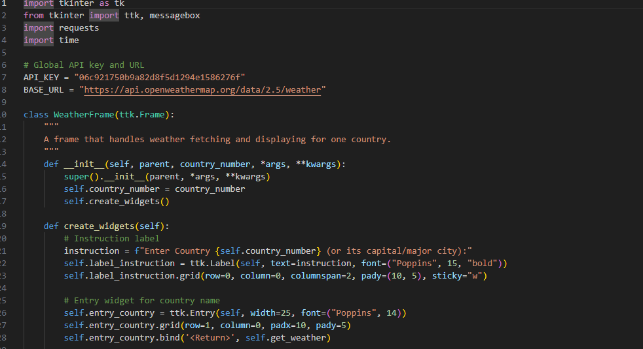

**Results**

**For One City:**

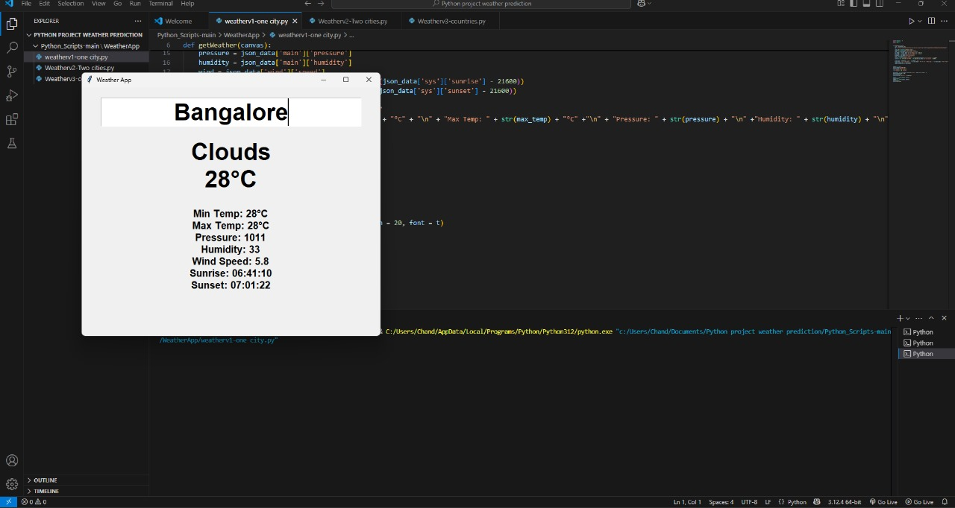

**For Two Cities:**

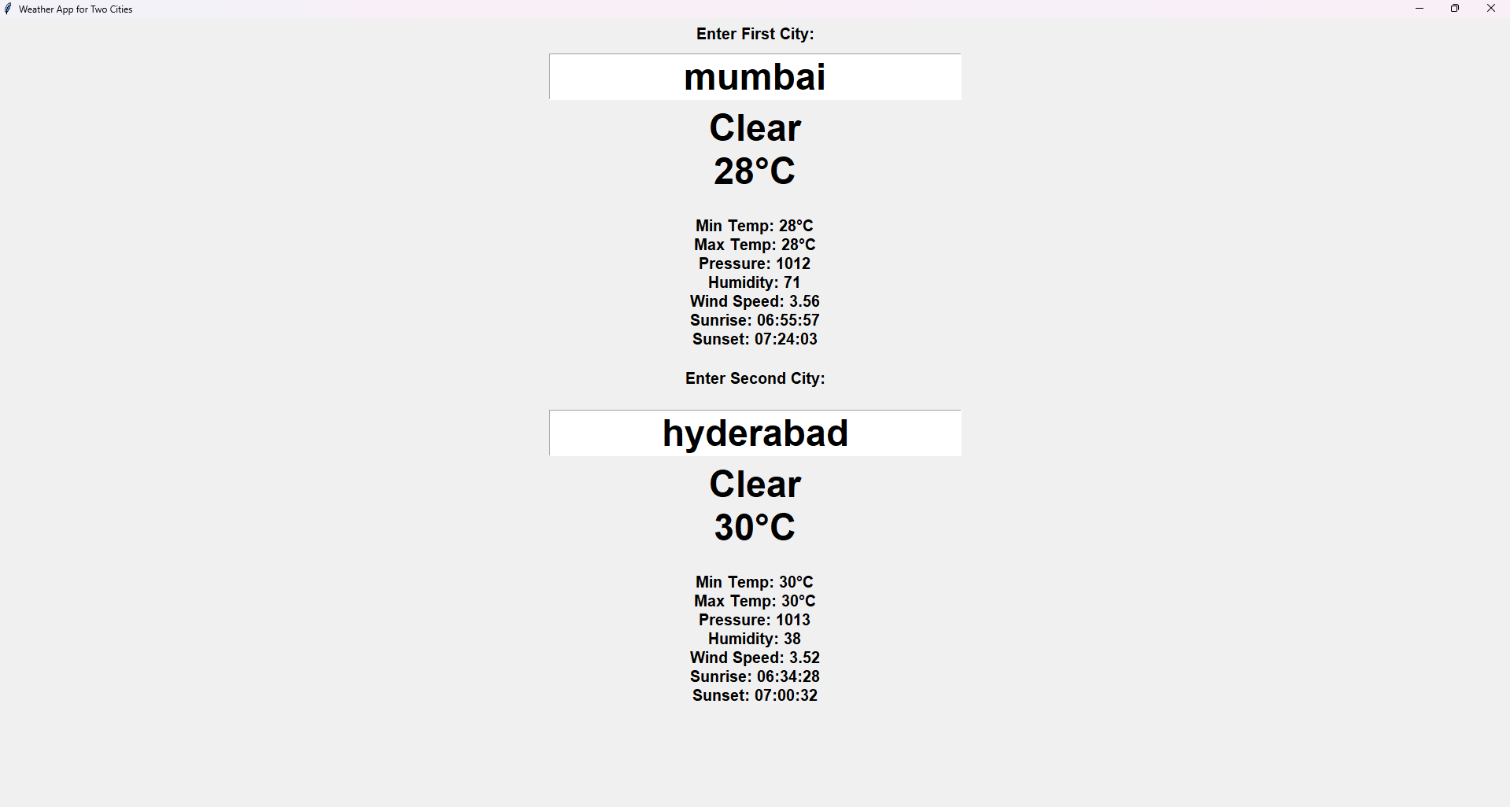

**For Different Countries And cities:**

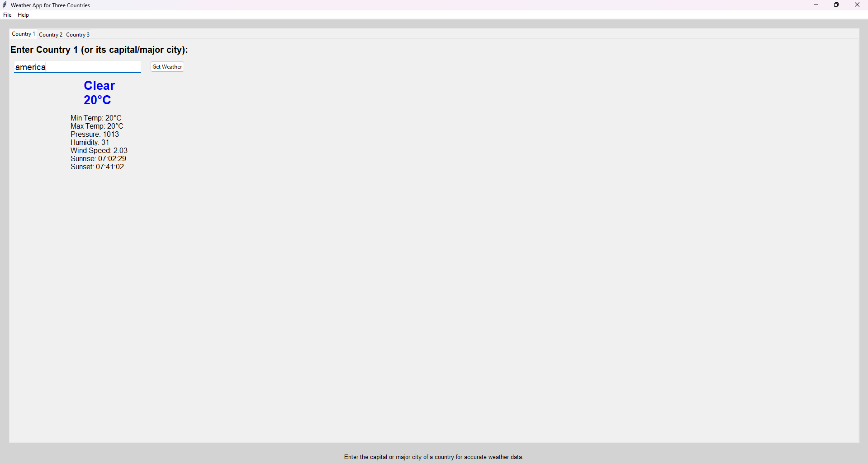

**Conclusion**

The AI-based weather forecasting project demonstrates improved accuracy and efficiency over traditional methods. By leveraging machine learning algorithms and historical data, it enables precise predictions, aiding disaster preparedness and daily planning. This approach marks a significant advancement in meteorology, offering scalable, real-time solutions for diverse geographical and climatic conditions.

**References**

1. Shi, X., et al. (2015). "Convolutional LSTM Network: A Machine Learning Approach for Precipitation Nowcasting."
2. Zhang, G. P. (2003). "Time series forecasting using a hybrid ARIMA and neural network model."
3. Dueben, P. D., & Bauer, P. (2018). "Challenges and design choices for global weather and climate models based on machine learning."
4. Agrawal, S., Barrington, L., & Branson, S. (2019). "Machine Learning for Precipitation Nowcasting from Radar Images."
5. eyn, J. A., et al. (2020). "Sub-seasonal forecasting with a large-scale neural network."